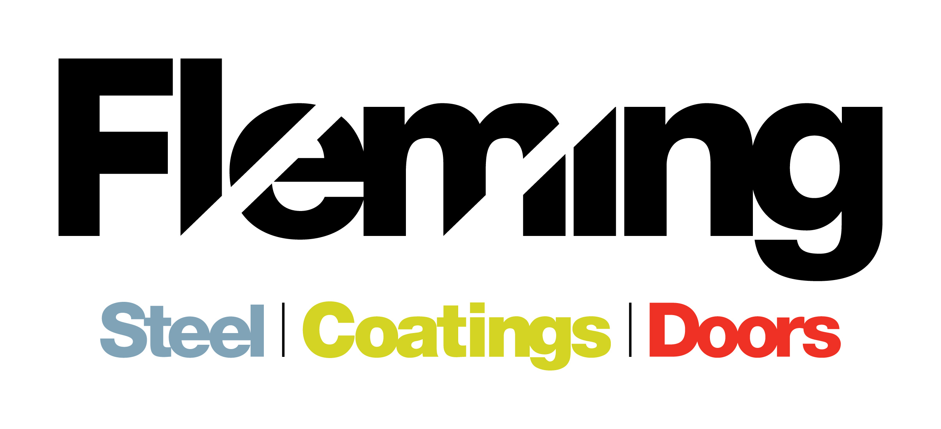

JOB VACANCY WITHIN THE FLEMING GROUP OF COMPANIES

Position: Accounts Administrator
JOB VACANCY: Fleming Engineering and Norwest Roofing are currently wishing to employ an Accounts Administrator to join their dynamic, innovative and hardworking team.
The Fleming group of companies based in St.Johnston, Co. Donegal consist of Fleming Steel, Fleming Doors, Fleming Coatings and a sister company based in Omagh, Norwest Roofing Systems. The group currently employ approximately 30 people.
Fleming Steel, primarily a retail business, has been the mainstay of the business for some 30 years and has developed to be the largest Steel Stockholder of Steel and Roofing products in the Northwest of Ireland.
Fleming Doors, over 12 years, has developed the ability to design, manufacture and install custom steel roller shutter doors. This subsidiary business has developed primarily through local knowledge and currently produces around five hundred doors annually. Custom manufactured doors have been designed, manufacture and installed for commercial, agricultural, industrial and private premises.
Fleming Coatings has developed the ability to provide a surface finish service for all things metal. Shot-blasting, Handblasting and chemical pre-treatment capabilities exist on site and are complemented by Wet-spray and powder coating facilities. Partnerships with local galvanising suppliers augment the service provided.
Norwest Roofing Systems Ltd was acquired in 2012 having been a supplier of Fleming Steel for 20 years. Based in Omagh, the company distributes Agricultural and Industrial roofing products such as Cladding, Rooflight and Flashings to contractors, merchants and the agriculture markets.
Company Structure
The group of companies has centralised financial, purchasing and administration control with dedicated sales and operations teams for each division who are overseen by a central steering team.

The role:
To work alongside the existing Financial Control team and Managing Director over 2 sites to maintain and continuously improve all aspects of the group’s financial control and MIS departments. Provide accurate and timely financial information to the management team

Principle Functions:

- Maintain all relevant ledgers, timely input of information to Sage and to ensure the accuracy of the information.
- Preparation of management accounts on a monthly basis to assist with the management of the business.
- The provision of monthly invoices, ensuring that all invoices are processed at regular monthly intervals.
- Preparation of bank reconciliations and liaise with the bank and treasury activities.
- Completion of statutory returns.
- Preparation of budgets and forecast financial performance in the business.
- Assist with Credit control management.
- Development of the company’s computerised MIS and advising on additions that will streamline computerisation.

Education and Experience:
- Accountancy qualification preferably with membership of a professional body e.g. CIMA, ACA, ACCA, ATI
And/Or
- A minimum of 3 years post qualification experience, ideally in a commercial environment
- A high degree of IT proficiency, preferably with experience in Sage Accounts and Sage Manufacturing
- Ability to plan and prioritise workloads to agreed deadlines
- Ability to communicate effectively at all levels
- Ability to work on own initiative

This is a permanent position with an immediate start date.
Salary is Dependent on Experience
Normal working hours are Monday – Thursday 8.30am – 5.30pm and Friday 8.30am – 3.30pm

Fleming Engineering and Norwest Roofing Systems are Equal Opportunity Employers

If you meet the requirements of this role and would like to apply, please e-mail lynda@fleming-steel.com on or before the 19th October 2016 with cover letter and cv.

