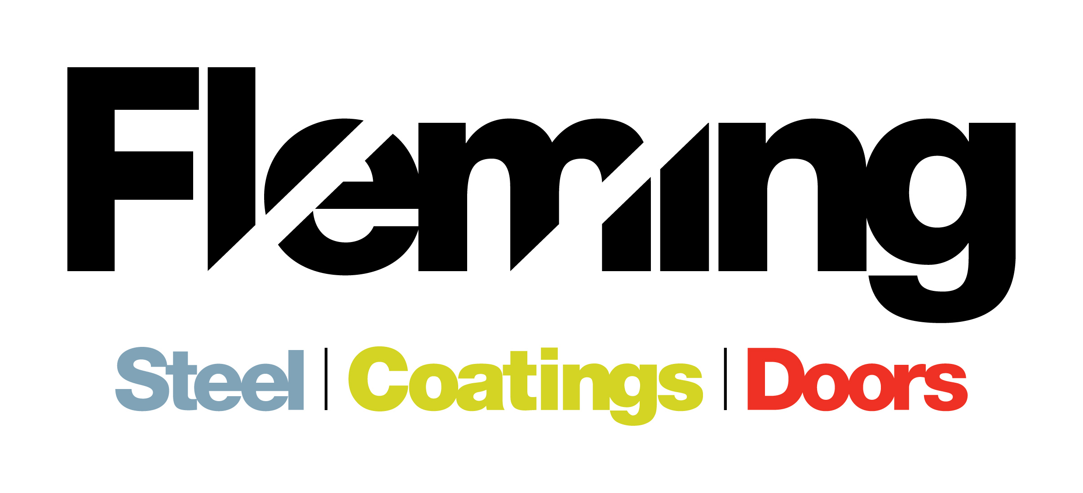

JOB VACANCY WITHIN THE FLEMING GROUP OF COMPANIES

Position: General Operative
JOB VACANCY: Fleming Engineering and Norwest Roofing are currently wishing to employ a General Operative for Fleming Steel.
The Fleming group of companies based in St.Johnston, Co. Donegal consist of Fleming Steel, Fleming Doors, Fleming Coatings and a sister company based in Omagh, Norwest Roofing Systems. The group currently employ approximately 30 people.
Fleming Steel, primarily a retail business, has been the mainstay of the business for some 30 years and has developed to be the largest Steel Stockholder of Steel and Roofing products in the Northwest of Ireland.
Fleming Doors, over 12 years, has developed the ability to design, manufacture and install custom steel roller shutter doors. This subsidiary business has developed primarily through local knowledge and currently produces around five hundred doors annually. Custom manufactured doors have been designed, manufacture and installed for commercial, agricultural, industrial and private premises.
Fleming Coatings has developed the ability to provide a surface finish service for all things metal. Shot-blasting, Handblasting and chemical pre-treatment capabilities exist on site and are complemented by Wet-spray and powder coating facilities. Partnerships with local galvanising suppliers augment the service provided.
Norwest Roofing Systems Ltd was acquired in 2012 having been a supplier of Fleming Steel for 20 years. Based in Omagh, the company distributes Agricultural and Industrial roofing products such as Cladding, Rooflight and Flashings to contractors, merchants and the agriculture markets.
Company Structure
The group of companies has centralised financial, purchasing and administration control with dedicated sales and operations teams for each division who are overseen by a central steering team.

The role:
To work alongside the existing general operatives and be responsible for the collection of customer steel and roofing orders safely, accurately and on time as well as the general maintenance of stock and housekeeping duties.

Principle Functions:

- Collecting stock for delivery / collection orders
- Assisting customers with order requirements
- Operating machinery.
- Loading/unloading lorries
- Inventory control
- Work within company guidelines for safe working practices & use of PPS
- Maintenance of machinery & record keeping
- Housekeeping
- Any other duties

The Person:
The ideal candidate would demonstrate the following within their c.v and interview
- Knowledge and experience of construction products
- Fork lift license
- Customer Service experience
- Ability to plan and prioritise workloads to agreed deadlines
- Ability to communicate effectively
- Ability to work on own initiative

This is a permanent position with an immediate start date.
Salary is Dependent on Experience
Normal working hours are Monday – Thursday 8.30am – 5.30pm and Friday 8.30am – 3.30pm
Fleming Engineering and Norwest Roofing Systems are Equal Opportunity Employers
If you meet the requirements of this role and would like to apply, please e-mail drew@fleming-steel.com on or before the 19th October 2016 with cover letter and c.v.

