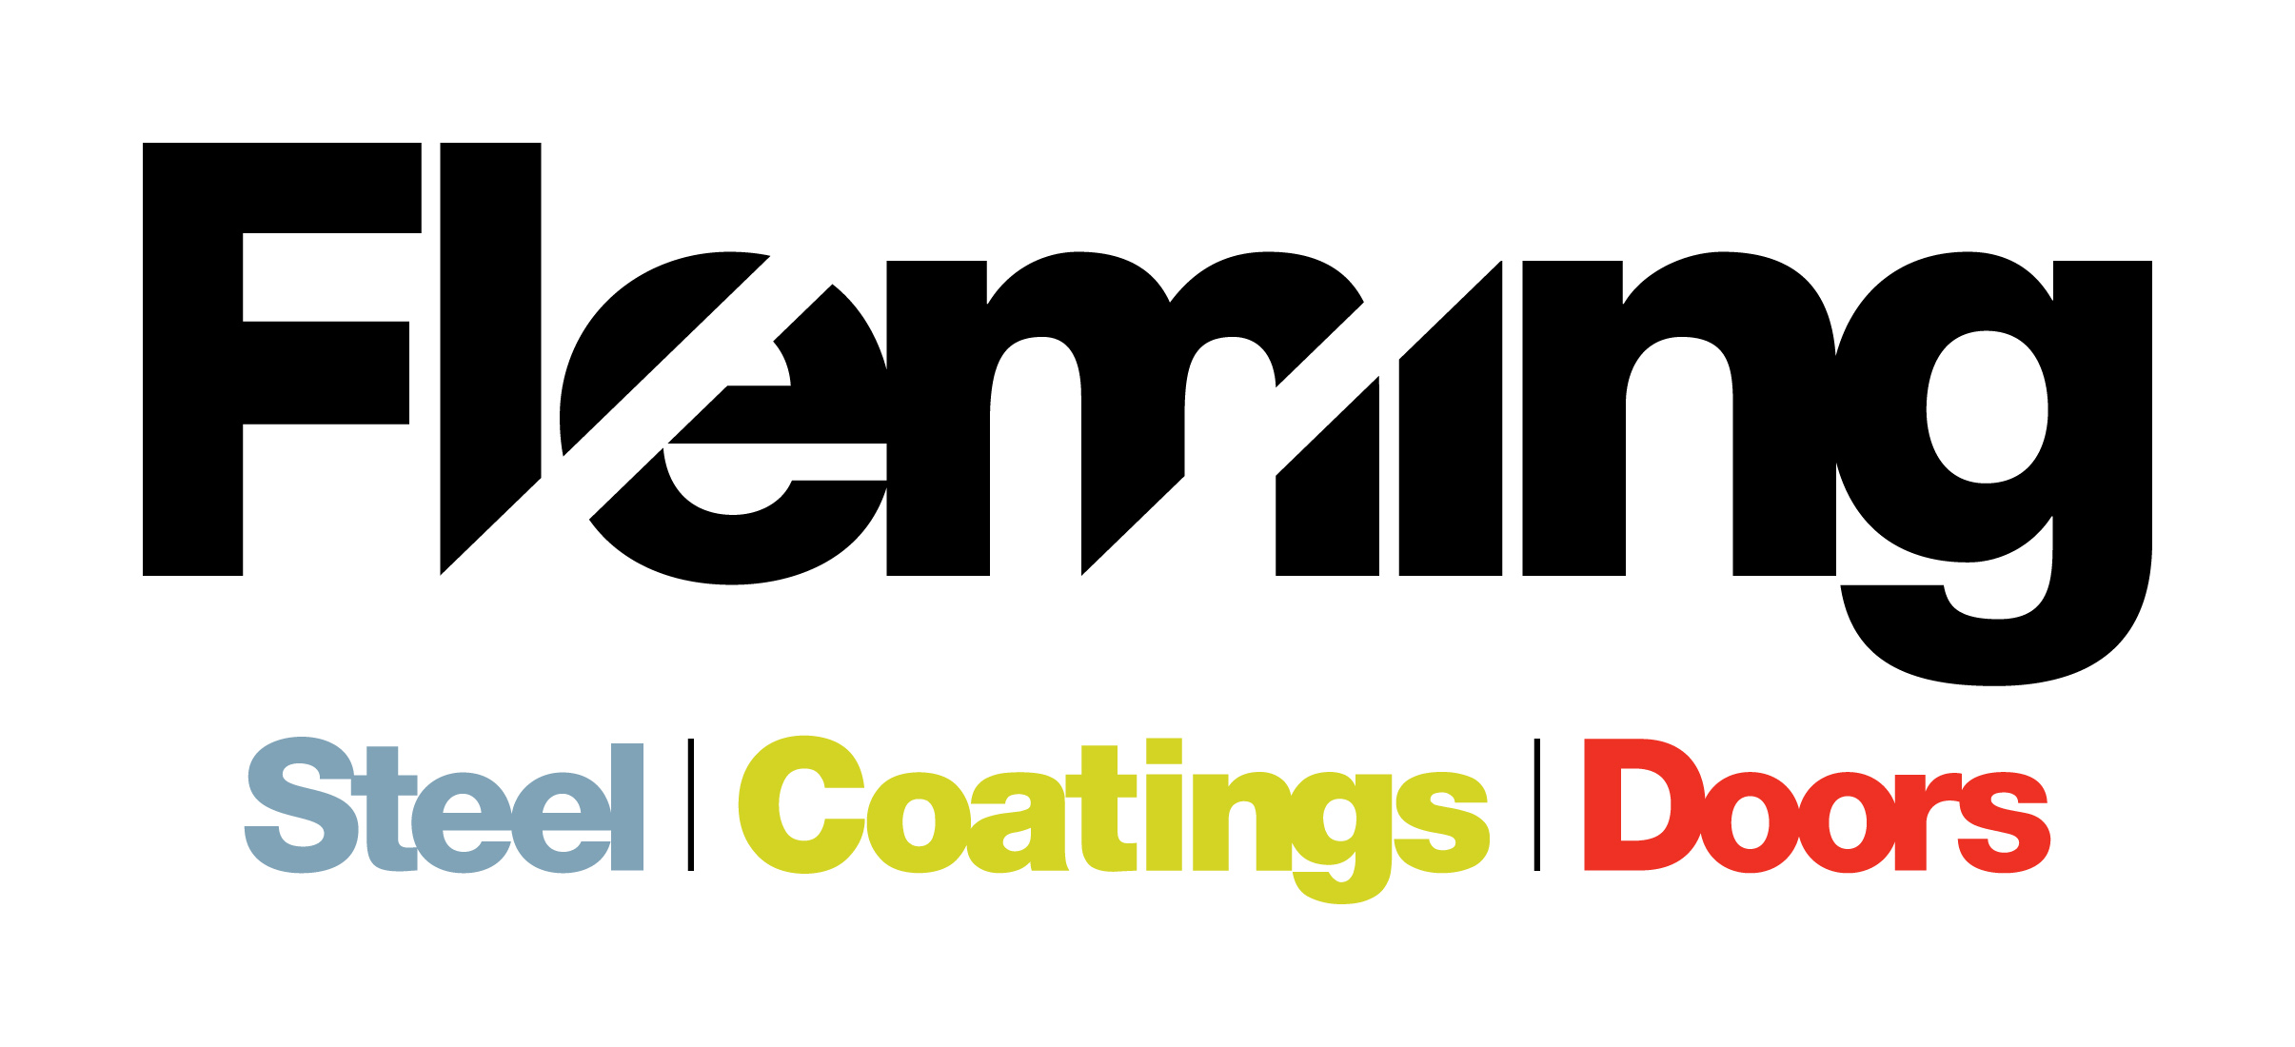

JOB VACANCY WITHIN THE FLEMING GROUP OF COMPANIES

Position: Powder Coating Operative
JOB VACANCY: Fleming Engineering are currently wishing to employ a Powder Coating Operative and Shotblasting operative for Fleming Coatings.
The Fleming group of companies based in St.Johnston, Co. Donegal consist of Fleming Steel, Fleming Doors, Fleming Coatings and a sister company based in Omagh, Norwest Roofing Systems. The group currently employ approximately 30 people.
Fleming Steel, primarily a retail business, has been the mainstay of the business for some 30 years and has developed to be the largest Steel Stockholder of Steel and Roofing products in the Northwest of Ireland.
Fleming Doors, over 12 years, has developed the ability to design, manufacture and install custom steel roller shutter doors. This subsidiary business has developed primarily through local knowledge and currently produces around five hundred doors annually. Custom manufactured doors have been designed, manufacture and installed for commercial, agricultural, industrial and private premises.
Fleming Coatings has developed the ability to provide a surface finish service for all things metal. Shot-blasting, Handblasting and chemical pre-treatment capabilities exist on site and are complemented by Wet-spray and powder coating facilities. Partnerships with local galvanising suppliers augment the service provided.
Company Structure
The group of companies has centralised financial, purchasing and administration control with dedicated sales and operations teams for each division who are overseen by a central steering team.

The role:
To work with the Powder Coating team and be responsible for pre-treatment, powder coating and packaging of products. The work also requires a high level of general maintenance of work space and housekeeping duties.

Principle Functions:

- Pre-treatment of product to be Powder Coated
- Application of Powder and Paint.
- Operating machinery.
- Loading/unloading lorries / vans
- Work within company guidelines for safe working practices & use of PPS
- Maintenance of machinery & record keeping
- Housekeeping
- Any other duties

The Person:
The ideal candidate would demonstrate the following within their c.v. and interview
- Experience of powder / Paint application
- Fork lift license
- Customer Service experience
- Ability to plan and prioritise workloads to agreed deadlines
- Ability to communicate effectively
- Ability to work on own initiative

This is a permanent position with an immediate start date.
Salary is Dependent on Experience
Normal working hours are Monday – Thursday 8.00am – 5.00pm and Friday 8.00am – 2pm
Fleming Engineering are Equal Opportunity Employers
If you meet the requirements of this role and would like to apply, please e-mail andrew@fleming-steel.com on or before the 14th March 2021 with cover letter and c.v.

